Leading cause of death in nc

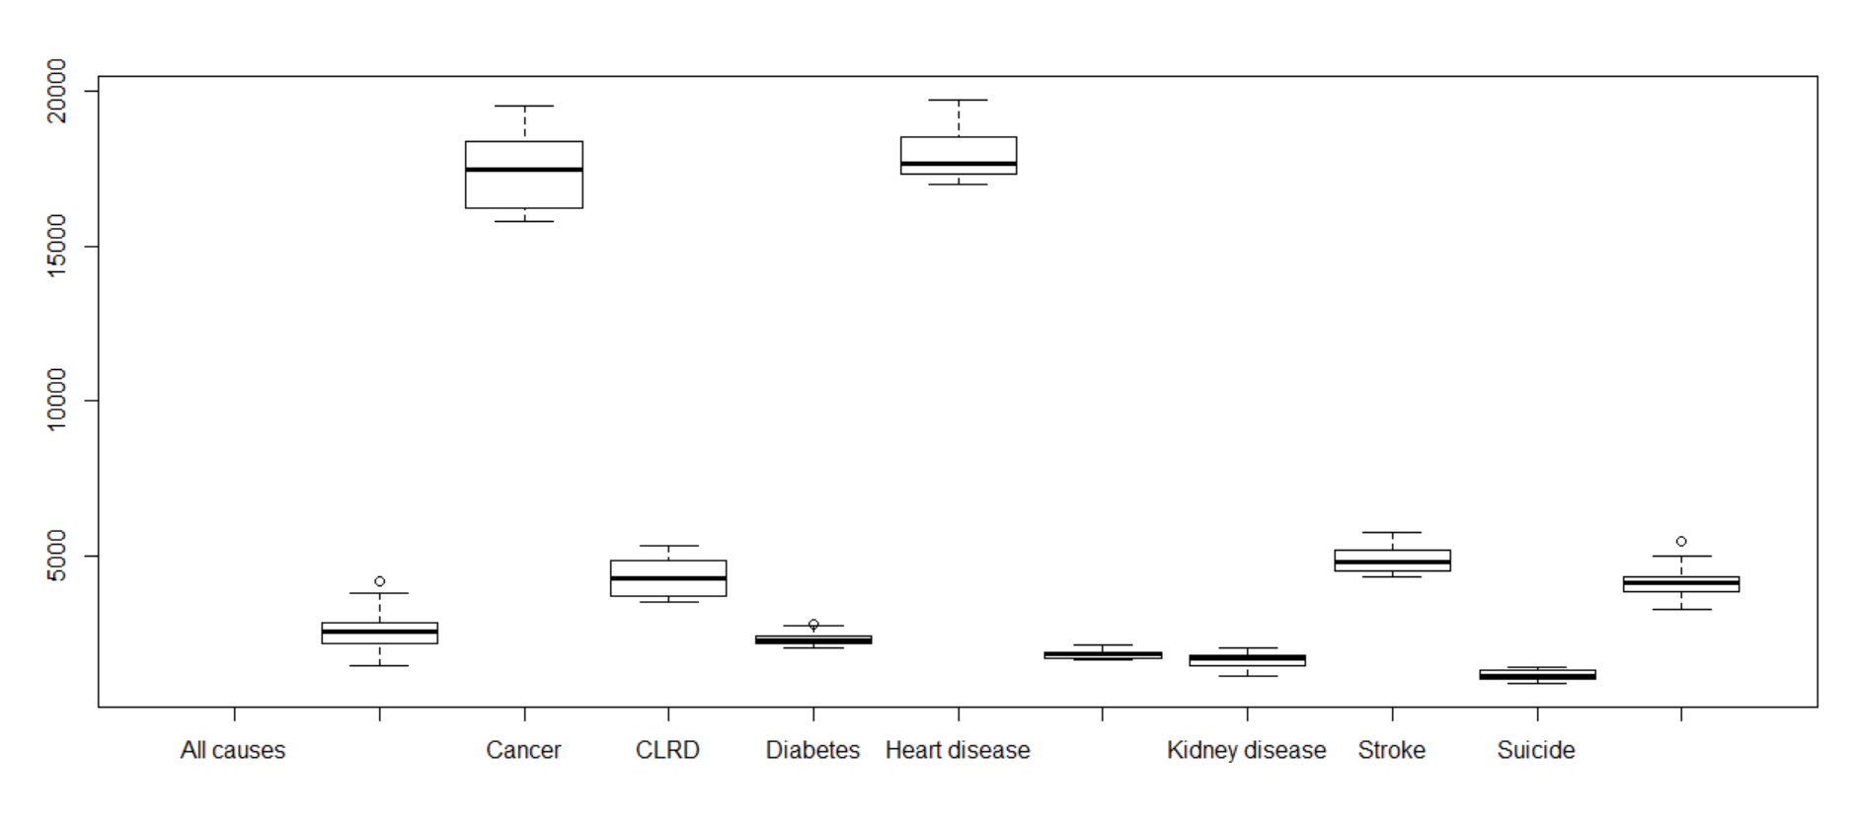

Top 3 for deaths

Mississippi

Alabama

West Virginia

Bot 3

California

Minnesota

Hawaii